Exercise 1:

1. create table DEPT(ID number(7),NAME varchar2(25));

output:

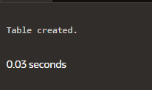

1. create table emp(ID number(7),LAST_NAME varchar2(25),FIRST_NAME varchar2(25),DEPT_ID number(7));

output:



1. alter table emp modify LAST_NAME varchar2(50);

output:

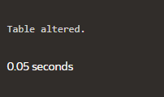

1. create table EMPLOYEES2(Id number(7),Last_name varchar2(25),First_name varchar2(25),Dept_id number(7),salary number(10));

output:

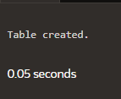

1. drop table EMP;

output:

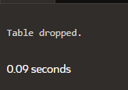

1. rename EMPLOYEES2 to EMP;

output:

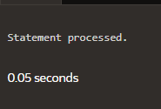

1. comment on table DEPT is 'This is department table';

comment on table EMP is 'This is Employee table';

output:



1. alter table EMP drop column First_name;

output:

